
How to Order Medicare Materials

PURPOSE: This job aid will show you how to order materials for PY2025.

Click the Agent Order Link
  The order system will open for 2025 material ordering July 12th for New Certs and Recertifications. Place order by 8/16 to receive materials by 9/30
  https://printandfulfillment.adp.com/HumanaDelegatedAgents/Forms/UniversalLogin.aspx
Login  Step 1  Step 2  Step 3 | 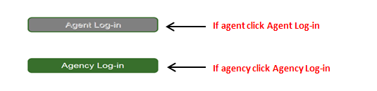  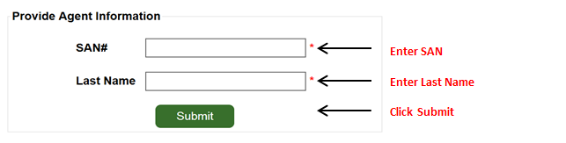  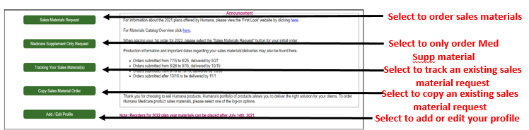
Choose your Plan Year | 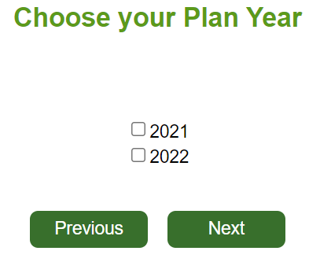  Select plan year  Click Next  2024  2025
Add Contact Information | 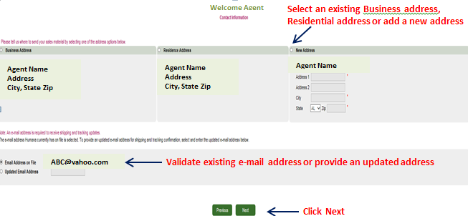
Choose your State and County | 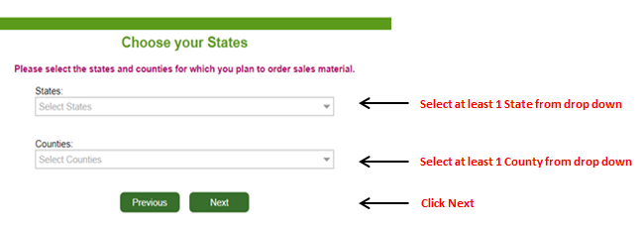
Choose your Materials - Plans | 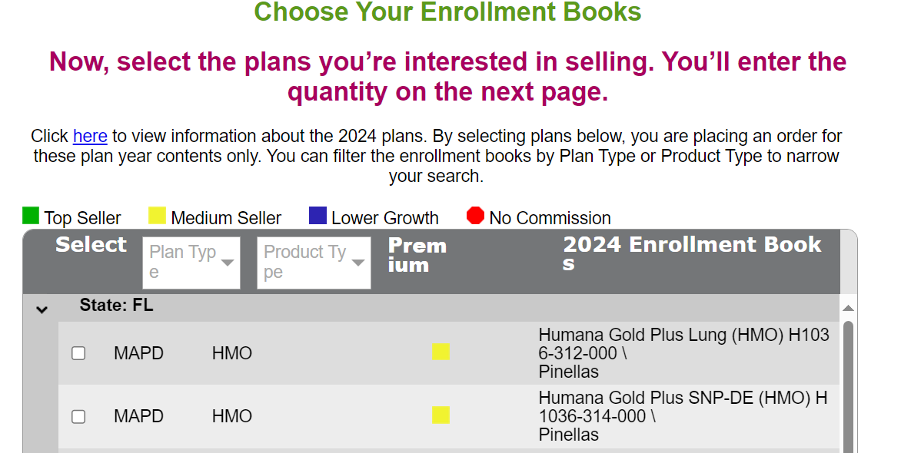  Choose your plan    Click Next
Choose your Quantity | 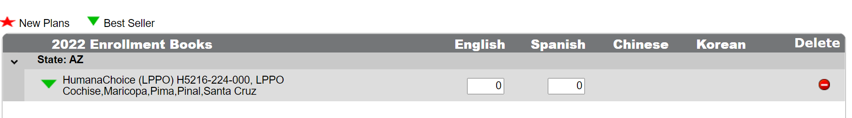    Click Next  Enter quantities:  Chinese and Korean boxes will only display if the plan is translated
Choose your Materials -Individual items  NOTE: Individual items may be applications, etc. | 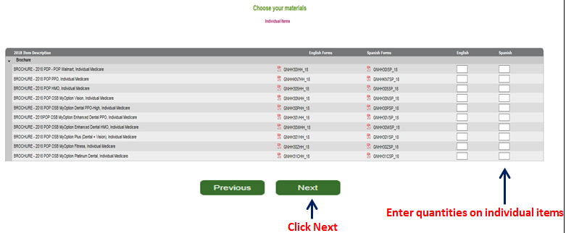
Choose your Materials – Medicare Supplement Items | 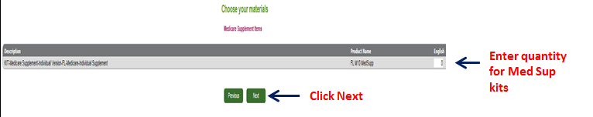
Review Order Summary | 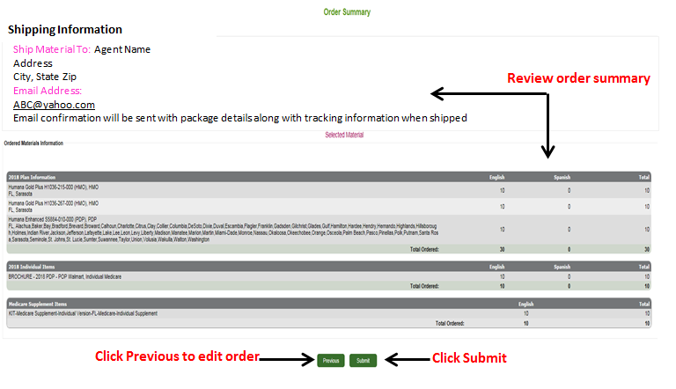
Confirmations | After you submit your order, you get 3 notifications:  - Immediately following your order, you will see the Order Confirmation screen letting you know that you have successfully completed your order  - You will receive an order confirmation e-mail after your order is submitted. The e-mail will go to the e-mail address provided in this order.  - Once your order has shipped, you will receive a shipping confirmation e-mail to the e-mail address provided on this order. You will be able to click on the order tracking link to track your order, once it’s shipped.
How to track you order | How to track an order job aid
How to copy and existing order | How to copy an order job aid
How to create a profile | How to create a profile job aid

