

Quality health plans &
Medicare Producer Certification Site User Guide Page 1
benefits
Healthier living Financial well-being

Individual Medicare Producers Certification User Guide

Easy Steps To Get Certified

Table of contents

Registration 3
Start your certification 7
Course tips 9
Changing your language preference 11
Profile updates 12
Changing your password 13
Seeing what you’ve completed 14
Start your certification Aetna Medicare compliance 16
training (AHIP alternative)
Aetna Medicare compliance training (AHIP alterna- 19 tive) Course tips

Registration
Your first step in becoming certified to sell Aetna’s Medicare products is to register on the site. Just follow these few steps and you’ll be ready to get started:

- New Users, click Create a New Account. Returning us-
ers, enter your Username and Password and click Login.
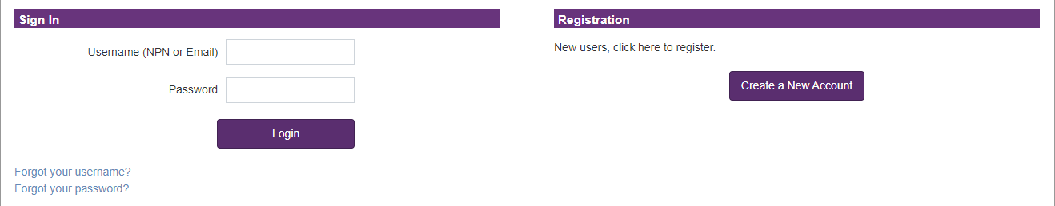





Returning Users
New Users
Please note, all returning users will need to request a password re- set upon first access to our training portal after 5/10/2021 due to updated password requirements. You can request this password reset using the Forgot you password? hyperlink, and then provide the email address that is on file within our certification portal.
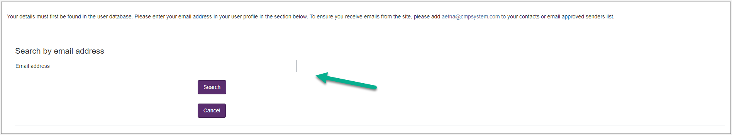
If you require assistance, the Broker Services may be reached at 1- 866-714-9301 Monday-Friday 8am to 8pm Eastern or by email at brokersupport@aetna.com.

- Alert the system if you are an Aetna employee or Front Runner:
  - Aetna employees: add your Aetna ID number into the text box and click Submit
  - 2023 Individual Medicare Front Runners: add your NPN into the text box and click Submit
  - Access Code Users: add your upline provided Aetna cer-
tification access code (if applicable) and click Submit
  - All other users: leave the text box empty and click Con- tinue Producer Registration

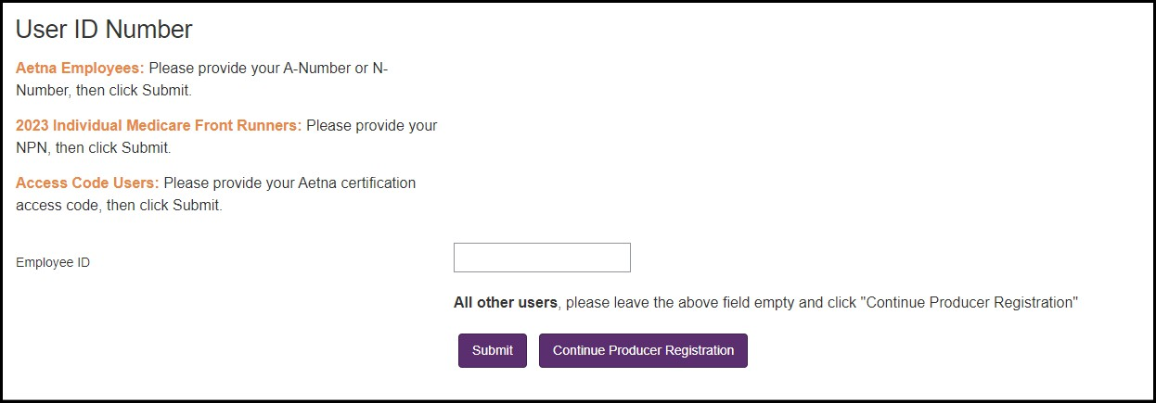

- Fill out the Confidential Information section of the reg- istration form and click Submit.
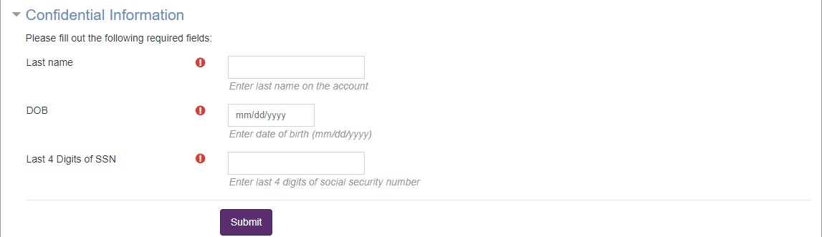

- Enter your first name into the indicated field and click
Find my NPN. This will automatically populate your
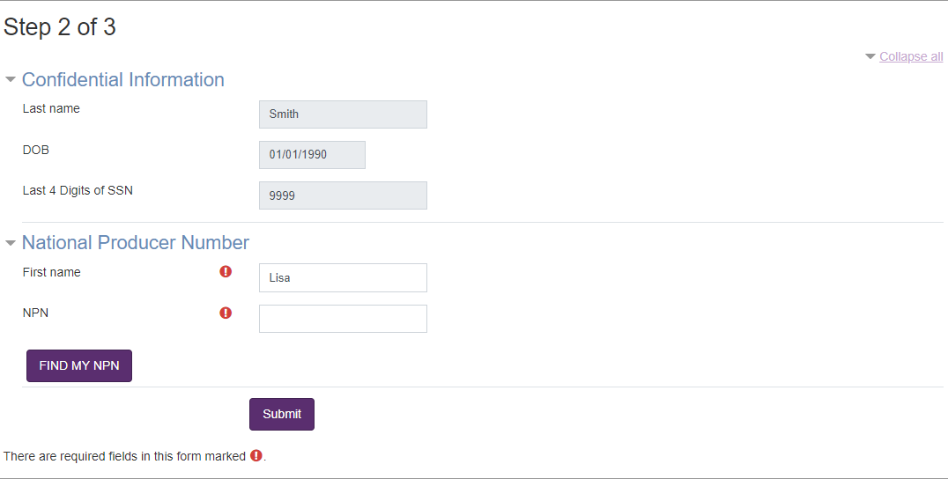
National Producer Number in the NPN field. Click Sub- mit to proceed.
- Complete the rest of the personal information fields and click Register
  - You will create a password as part of creating your pro- file. Be sure to make a note of your password for fu- ture reference.

- Make a note of your Username, which you’ll use when logging into the site the next time, and then click Con- tinue to Home
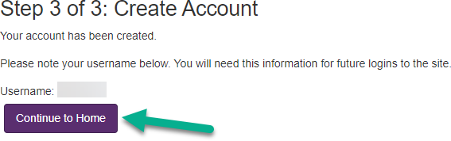

Your registration is now complete. You only have to fill out this information once.

The next time you visit the site, you can use your Username
and password to log on and return to your certifications.

A Note to Aetna A and N number users: If you have not
certified as an Aetna employee in the past, you may need to contact Aetna Brokers Services to add your A/N Number to the site before it will be recognized. Broker Services may be reached at 1-866-714-9301 Monday-Friday 8am to 8pm East- ern or by email at brokersupport@aetna.com.

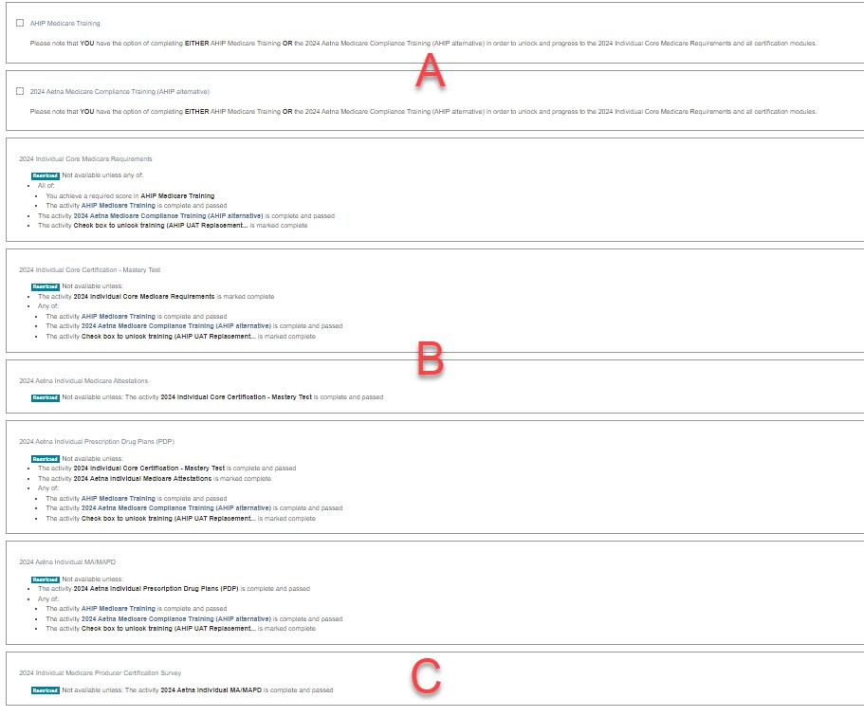
Start your certification
Your certifications can be accessed from the main page under the My Certifications section. You will find the 2024 Aetna Individual Medicare Certification and a progress wheel that
will display the percentage of the training courses that have been completed.
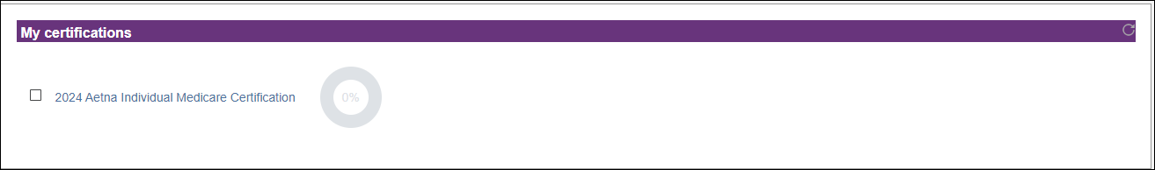

- Aetna certification requires that you complete either
AHIP Medicare training or Aetna Medicare Compliance training (AHIP alternative) before taking the Aetna In- dividual Medicare training. If you have already com- pleted AHIP Medicare training as part of another certi- fication, this will be marked as complete here as well.
- You’ll walk through the certification process one step at a time. Once you complete a step, the next section becomes available to you.
- You’re asked to fill out a short survey about your certi- fication experience. The survey is locked until all sec-
tions are complete, but is not part of the certification
requirements. You can obtain your certification with- out filling out the survey.

So now that you’re familiar with the layout of the certification, how do you get started?
Simply click on a blue course title to access the training mate- rials for that section. If a course is showing as restricted, it
cannot be accessed until all prerequisites are complete.

Course tips
Your certification has two types of sections: training courses and mastery tests. When you click on the section title, the
training course or mastery test begins. Here are some tips to help you get the most out of your training time.

Training courses
Use the forward and back buttons to move through the train- ing courses. You can also use the menu on the left to go back to any of the pages that you’ve already seen.
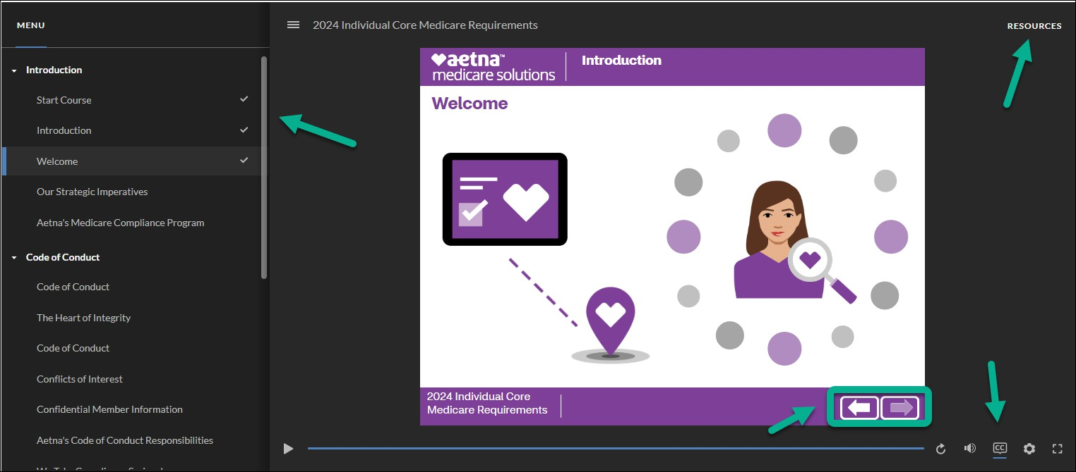

Courses include recorded audio, closed captioning, and viewable tran- scripts. You can access closed captioning by clicking on the CC in the bottom right corner. Transcripts are available by clicking Resources in the top right corner.

When you get to the end of a training course, you can review the course, or you can navigate using the Return to main
training button, or Next step button located above the train- ing screen.
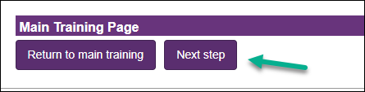

Mastery tests
You’ll want to be sure that you understand each training
course. This is done by taking the mastery test.

It’s so important that you understand this information that you’ll need to get a score of 90% or better on the Core mas-
tery test while a score of 80% or better is needed on the PDP
and MA/MAPD/SNP mastery test. Once you get a passing score, the test is marked complete on your certification.

You have three attempts to pass each mastery test.
If you leave the test before you finish, your answers will not be saved and you will have to start the test over from the beginning. However, you will not be charged an at-
tempt.

Changing your language preference
We have two language options, English (default) and Spanish for both the 2024 Aetna Medicare Compliance Training (AHIP alternative) and the 2024 Aetna Individual Medicare Certifica- tion. To change your language preference click the language on the menu and select your language.
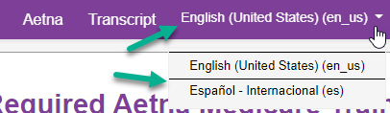

After you select the preferred language your training modules and exams will update.
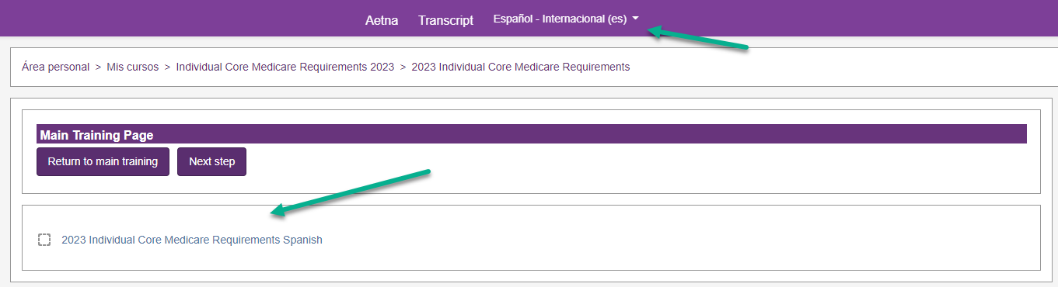

Profile updates
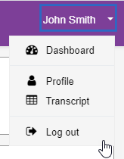
When you register on the site, you record details about yourself and the certification you want to complete.
You can change any of those details by se- lecting your name in the top right corner, and then selecting Profile from the dropdown box.

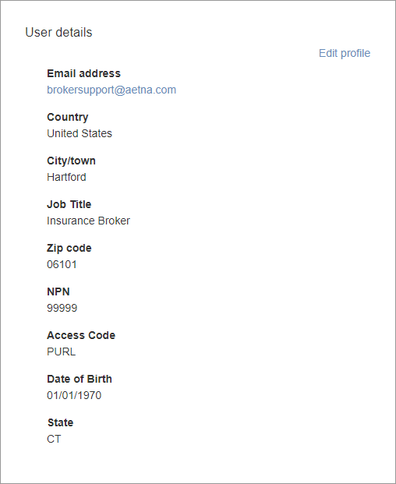
You can look at and
change your information stored on the site in your profile. This includes changing your password. To make any changes, you
will need to select the edit profile button.

Changing your password
To change your password, simply click on your name in the top right of your screen, and selecting Profile from the drop down list.

- On the profile page, click Edit Profile.
- You can now type in your new password information, and then select Update profile at the bottom to con- firm the changes.
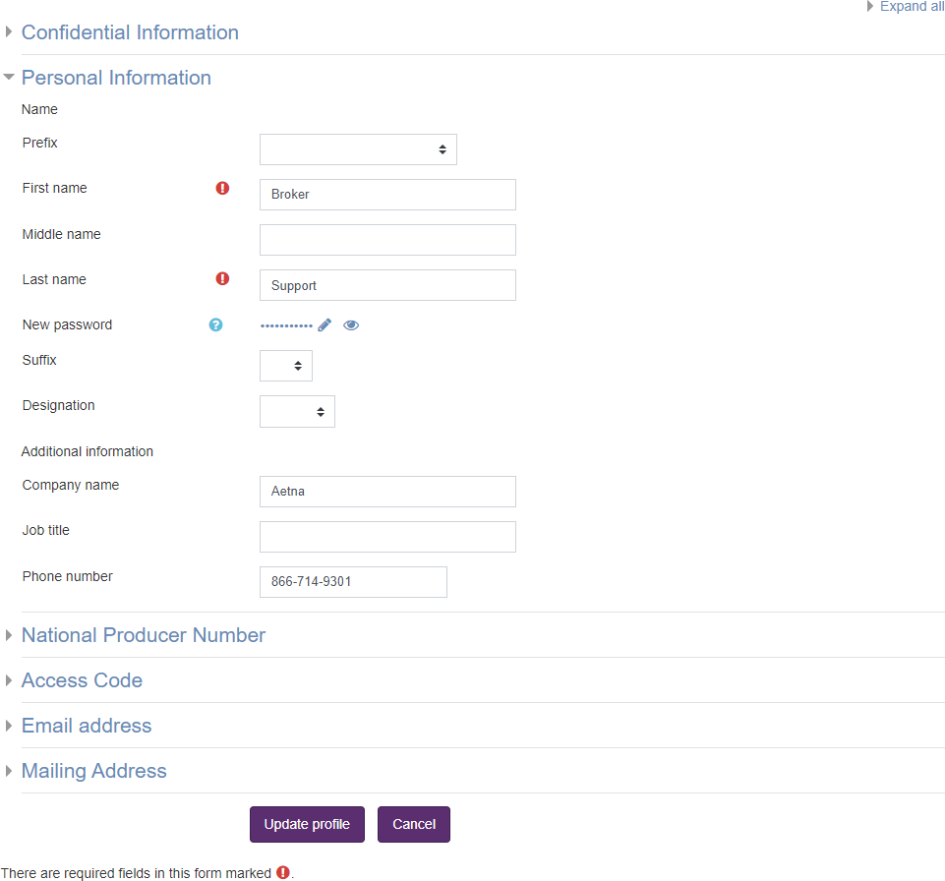

Seeing what you’ve completed
You can see what you’ve completed by clicking on Transcript
on the bar at the top of the screen, as well as within your pro- file.
Once you have completed a certification, you can view your
certificate from your transcript at any time.
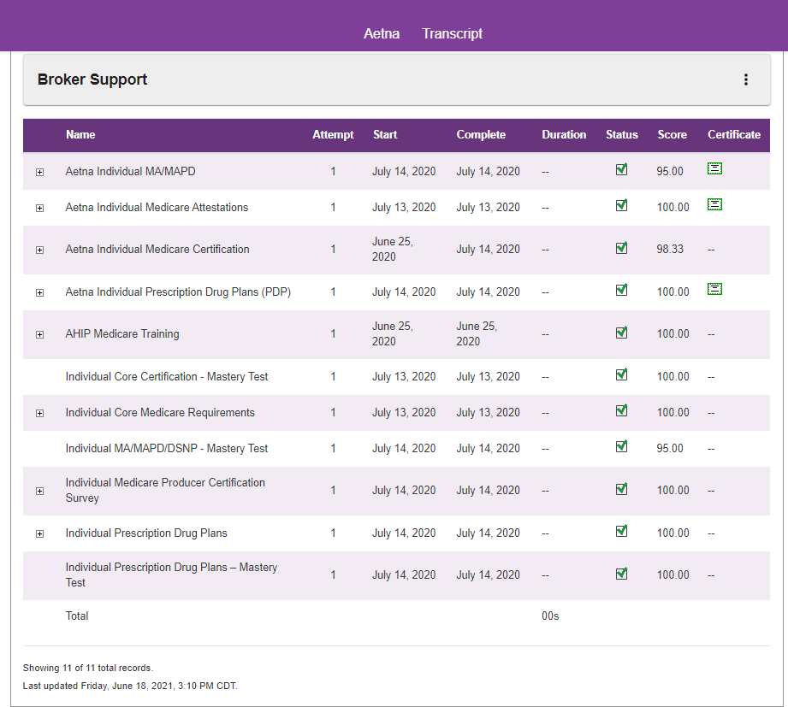

To print your certificate, click on the printer icon next to the download option in the upper right corner. You can also print by right click with your mouse to see the print option.

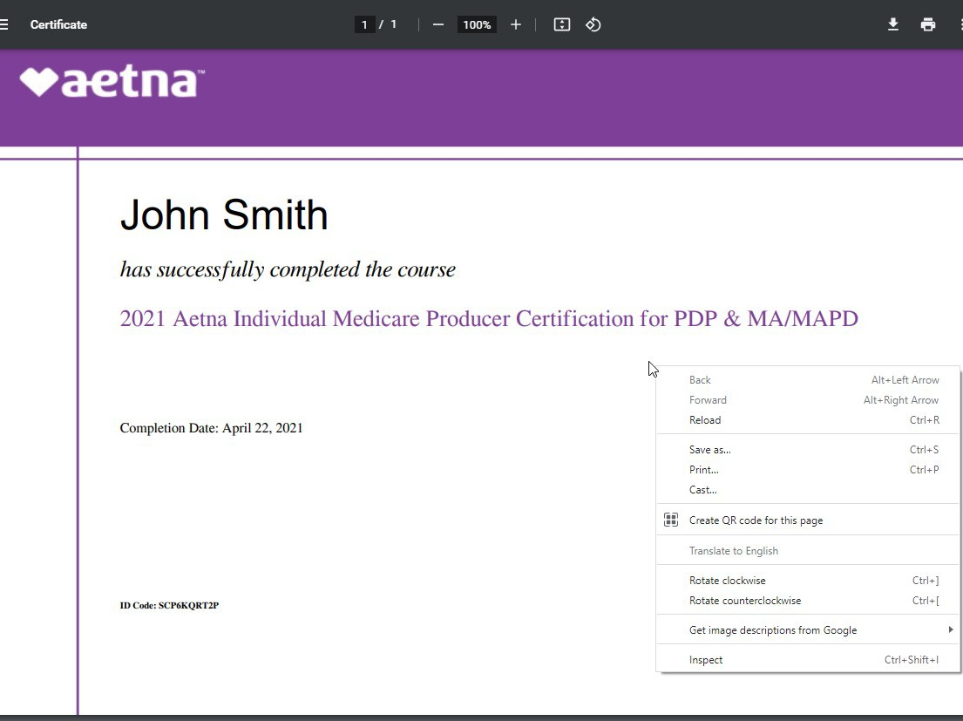

Starting the Aetna Medicare Compliance Training (AHIP alternative)

The Aetna Medicare Compliance Training (AHIP alternative) can be accessed from the main page under the Aetna Medicare Compliance Training (AHIP alterna- tive) section. In this section you will click here to be enrolled in the training.
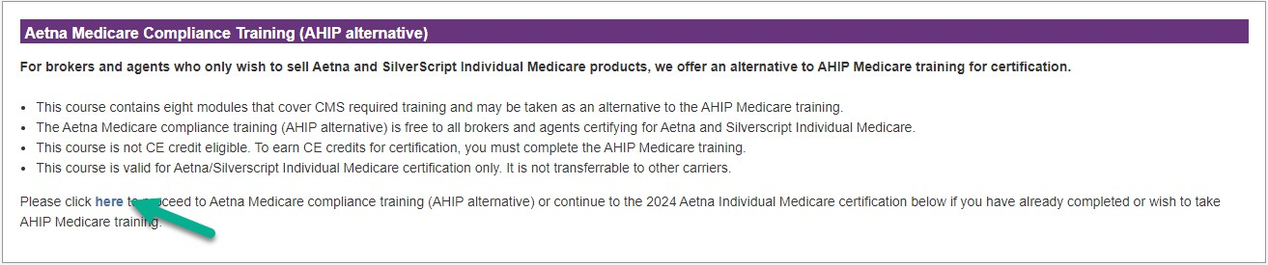
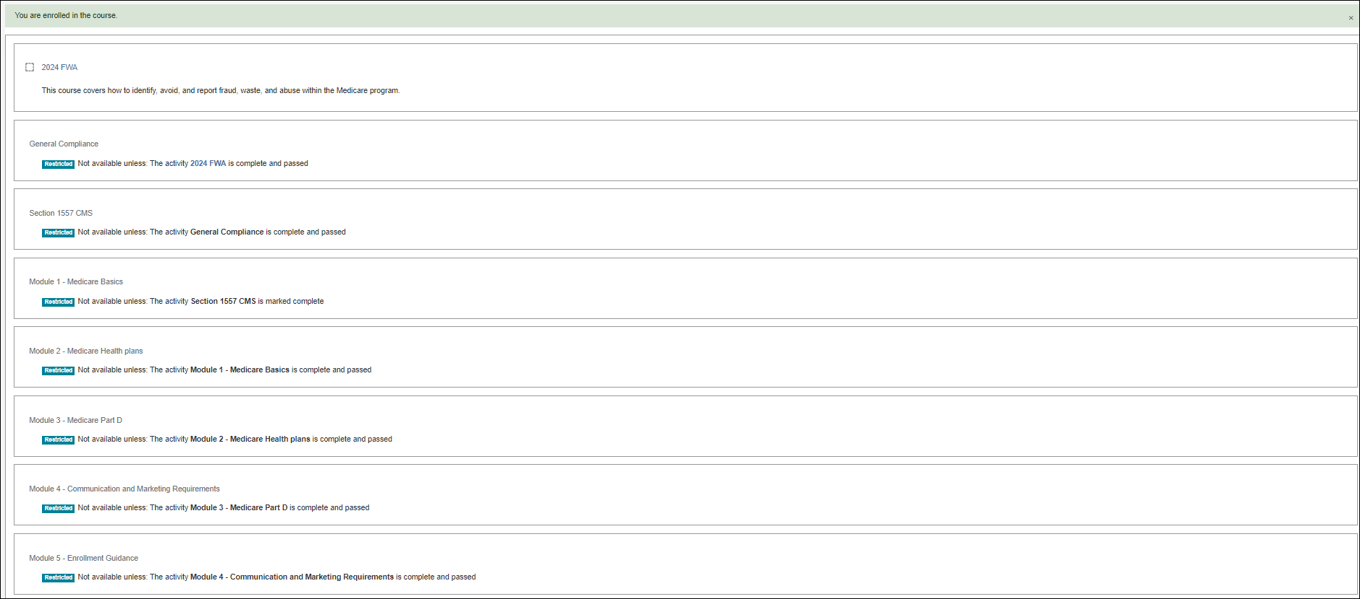

After enrolling you will find the 2024 Aetna Medicare Compliance Training (AHIP alternative) and a progress wheel that will display the percentage of the training courses that have been completed under the My Certifications section.
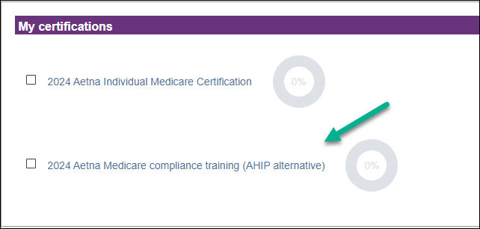

- This course contains eight modules that cover CMS required train- ing and may be taken as an alternative to the AHIP Medicare train- ing.
- The Aetna Medicare Compliance Training (AHIP alternative) is free to all brokers and agents certifying for Aetna and Silverscript Indi- vidual Medicare.
- This course is not CE credit eligible. To earn CE credits for certifica- tion, you must complete the AHIP Medicare training.
- This course is valid for Aetna/Silverscript Individual Medicare certifi- cation only. It is not transferrable to other carriers.

Once you complete the Aetna Medicare Compliance Training (AHIP alternative) return to your dashboard. You will now see the progress wheel showing 100% completed. Now you
must complete the Aetna Core training as well as the Aet-
na Medicare Advantage and/or SilverScript PDP product courses to become fully certified.
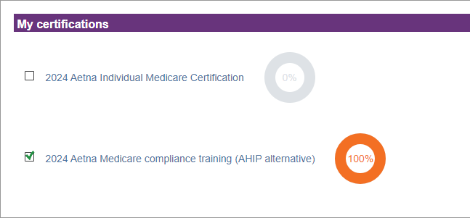
Return to your training home page by clicking Aetna in the
top navigation bar. Then click 2024 Aetna Medicare Training under My certifications and you will now see the 2024 Core Medicare Requirements unlocked.
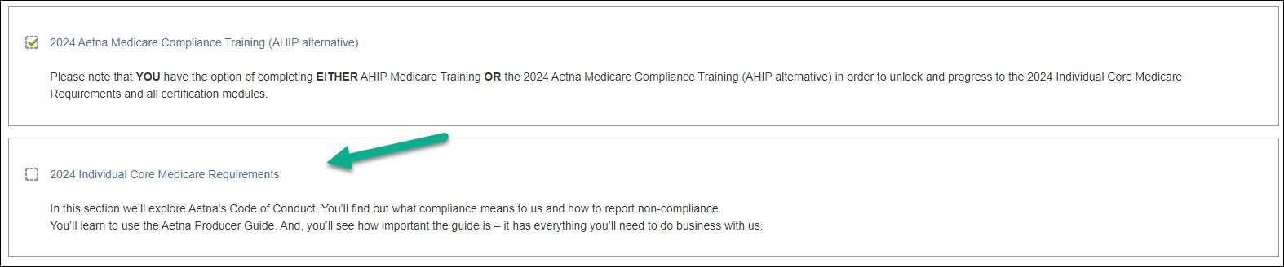

Course tips
Your certification has two types of sections: training courses and mastery tests. When you click on the section title, the
training course or mastery test begins. Here are some tips to help you get the most out of your training time.

Training courses
Use the forward and back buttons to move through the train- ing courses. You can also use the menu on the left to go back to any of the pages that you’ve already seen.
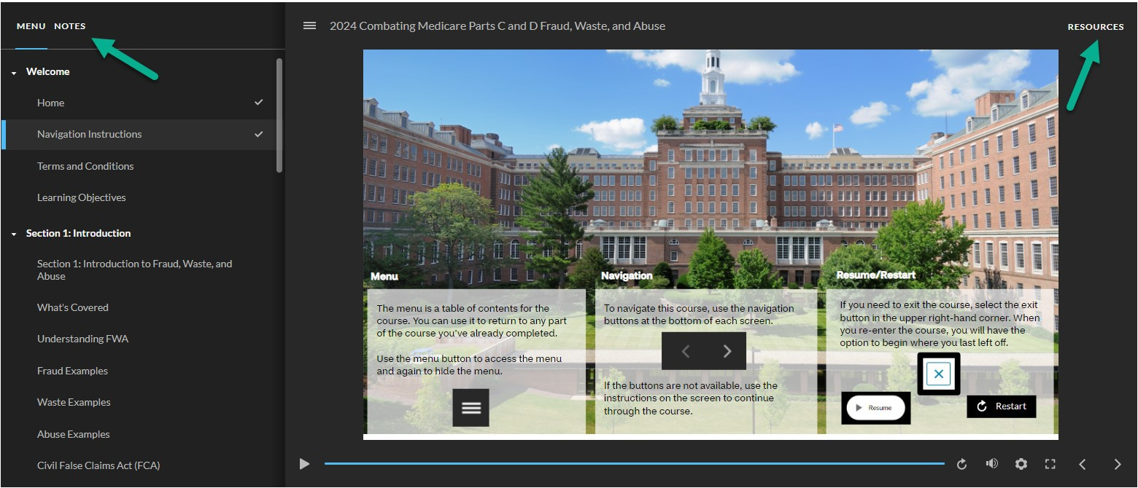

Courses include recorded audio, closed captioning, and viewable tran- scripts. You can access closed captioning by clicking on Notes next to Menu in the top left corner. Transcripts are available by clicking Re-
sources in the top right corner.

When you get to the end of a training course, you can review the course, or you can navigate using the Return to main
training button, or Next step button located above the train- ing screen.

Mastery tests
You’ll want to be sure that you understand each training course. This is done by taking the mastery test.

It’s so important that you understand this information that you’ll need to get a score of 90% or better on the mastery test. Once you get a passing score, the test is marked com- plete on your certification.

You have three attempts to pass each mastery test.

If you leave the test before you finish, your answers will not be saved and you will have to start the test over from the beginning. However, you will not be charged an at-
tempt.

