Producer Onboarding
Table of Contents
Introduction 2
Login 2
Confirm Your Identity 3
General Information 4
Contact Information 4
Licenses 5
Background Check 6
Errors and Omissions (E&O) Insurance 6
AHIP 7
Compliance Policies 8
Sales Policies 9
W-9 Form 10
Banking Information 11
Product Training 11
Sign Documents 12
Completion 12

Introduction
The onboarding module allows you to submit your annual certification for our Medicare Advantage plans. Once you complete this process, you are Ready to Sell (RTS) for the plan year.
Onboarding is available from the dashboard when you’re logged into the portal.

Login
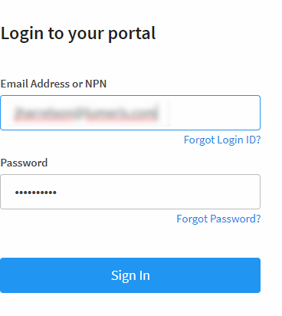
Enter your Email Address or NPN and your password, and then click Sign In.
The blue box will let you know whether you are ready to sell; if you’re not yet certified for the plan year, you can get started now.
Click Start Onboarding to begin.


Confirm Your Identity
If you’ve been certified for a prior year, some information will populate for you during the onboarding process. The first screen you encounter (shown below) will list what you need to complete the process.
Enter your social security number (SSN) and any other information that is not pre-populated. Check the box to authorize and click Get Started to move forward.
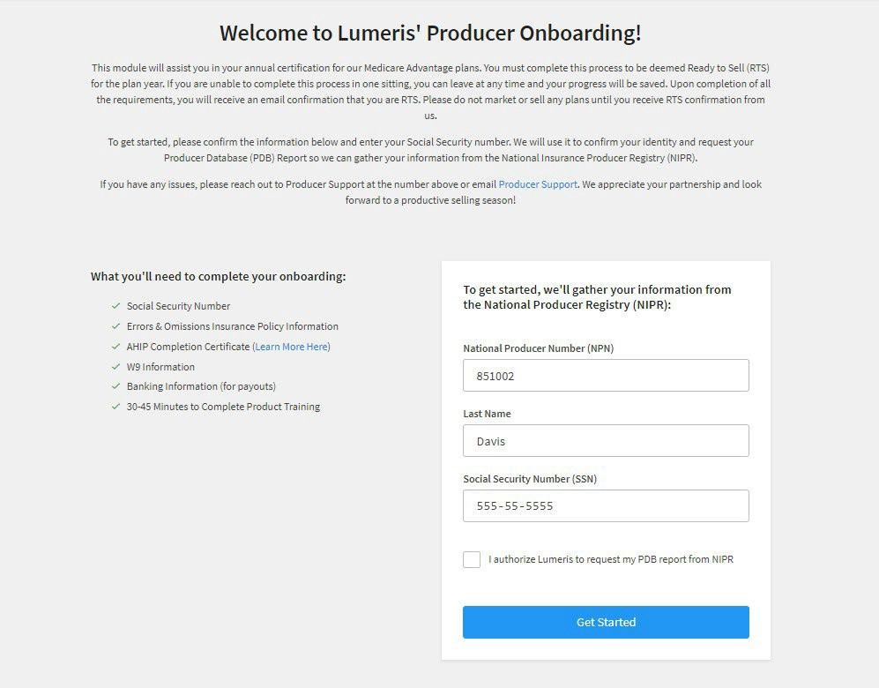

From this point forward, you will continue filling out the form. Each step must be completed before you can move forward.

General Information
In this first section of the form, complete any required fields (some will populate based on prior year certification if applicable). Click Continue and Save to move forward.
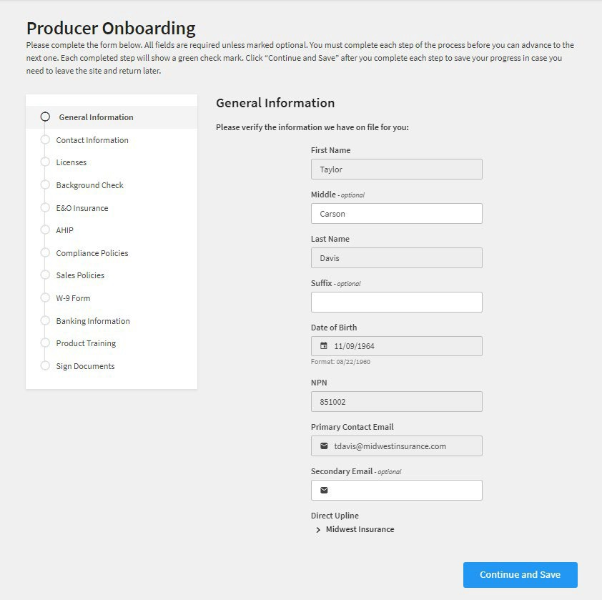

Contact Information
Complete any required fields (some will populate based on prior year certification if applicable). Click
Continue and Save to move forward.
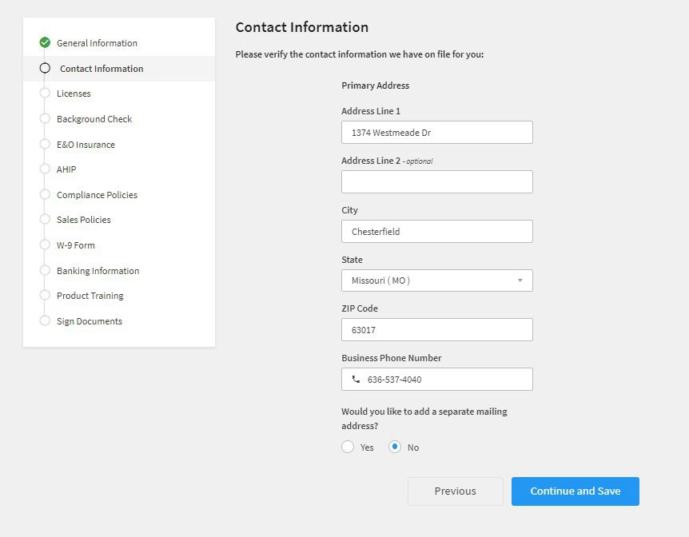

Licenses
Existing licenses that correspond with states where we currenly offer products will display on this page.
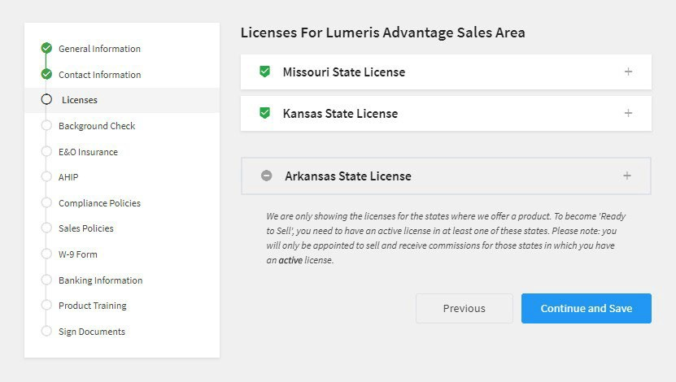
Click the plus signs next to a license listing to see the details.
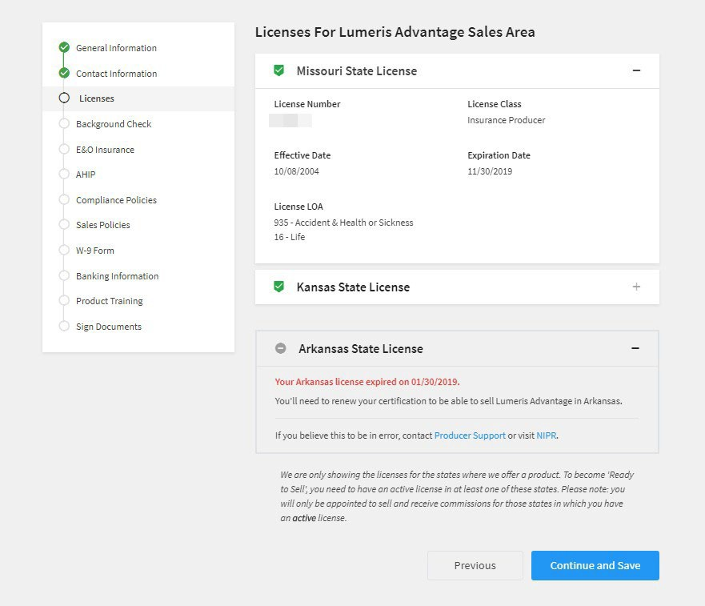
Previously held licenses will appear without the green checkmark as shown above. Expired licenses must be renewed in order for you to sell in those states.

Background Check
For each form listed on this page, click View and Sign to display the form. Type your name for your electronic signature and click Complete. Repeat the process for each agreement and then click Start Background Check.
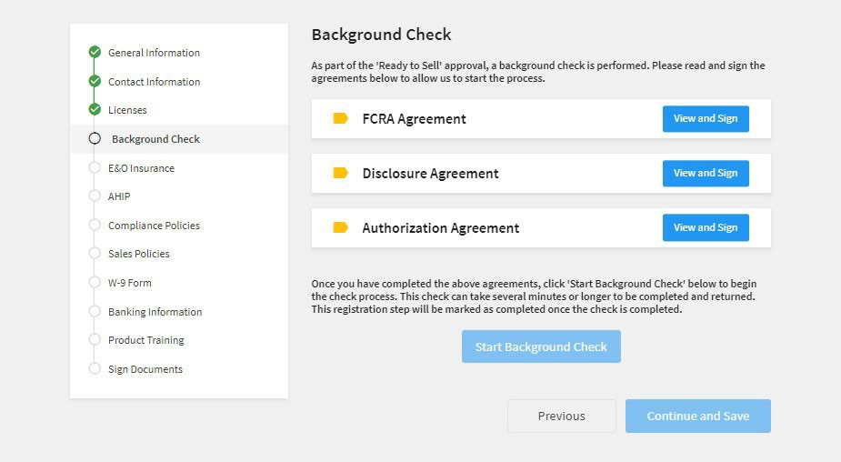
Once the Background Check has been started, click Continue and Save to move to the E&O Insurance page.

Errors and Omissions (E&O) Insurance
Complete any required fields (some will populate based on prior year certification, if applicable). Click
Continue and Save to move forward.
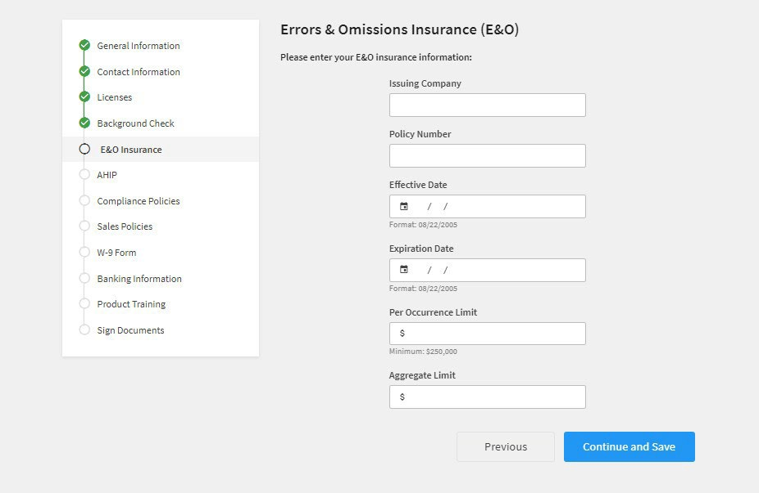

AHIP
In order to become “Ready to Sell”, you must complete America's Health Insurance Plans
(AHIP) Marketing Medicare Advantage and Fraud, Waste and Abuse certifications. If you have not completed the certification, click the link on this screen to visit AHIP.
If you have your completed AHIP certificate, please upload it on this page. Enter the date that you completed the AHIP training and only upload the certificate for the most current plan year as shown.
Enter your name as an electronic signature, enter the date and click Continue and Save to move forward.
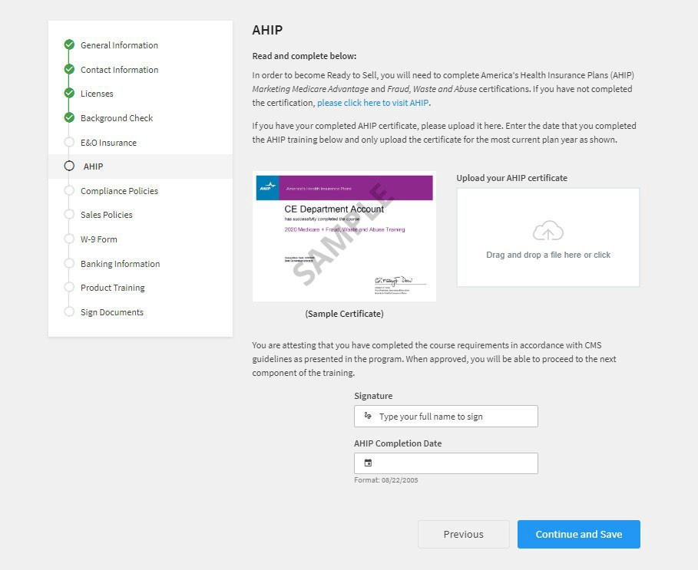

Compliance Policies
In order to comply with Compliance Policy and Procedures (P&Ps), click each document link from this page and review the content.
When you’re finished, review the acknowledgement statement. Enter your name as an electronic signature, enter the date and click Continue and Save to move forward.
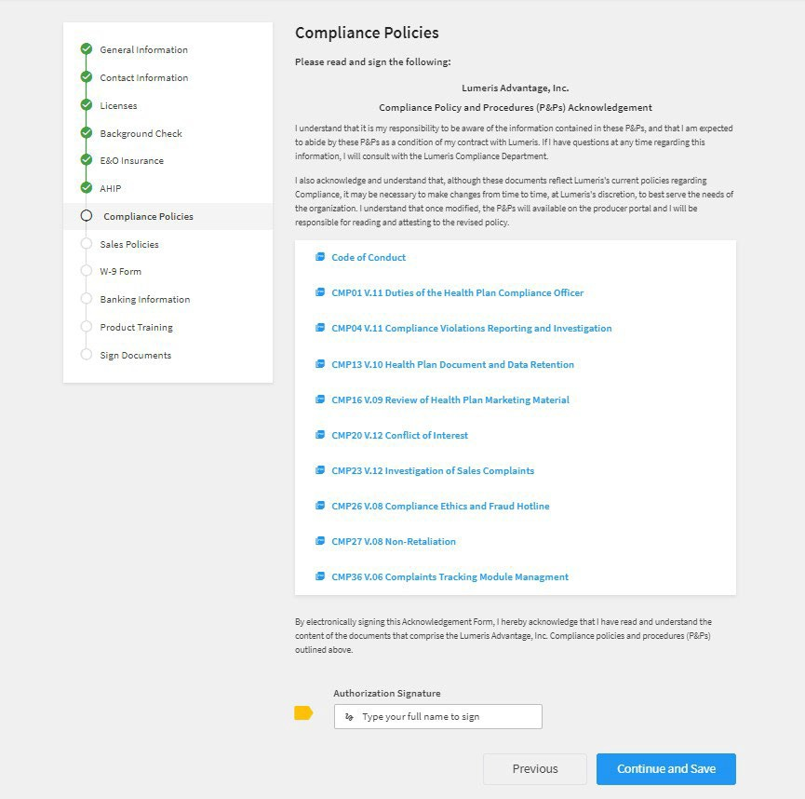

Sales Policies
In order to comply with Sales Policy and Procedures (P&Ps), click each document link from this page and review the content.
When you’re finished, review the acknowledgement statement. Enter your name as an electronic signature, and click Continue and Save to move forward.
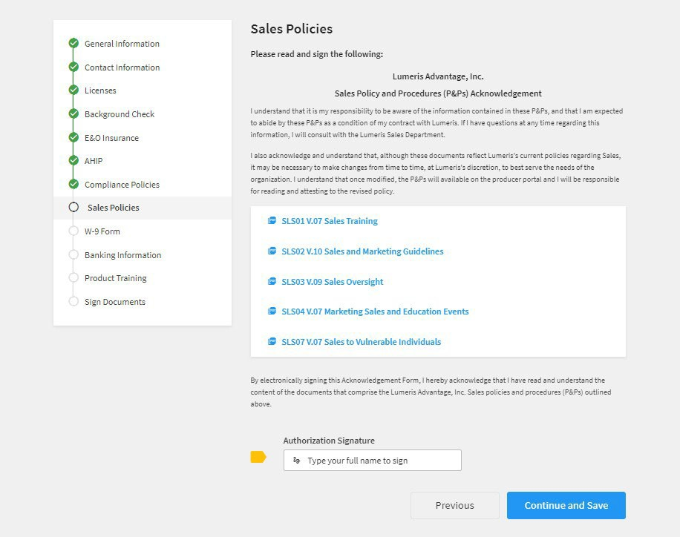

W-9 Form
Complete any required fields (some will populate based on prior year certification, if applicable). Click
Continue and Save to move forward.
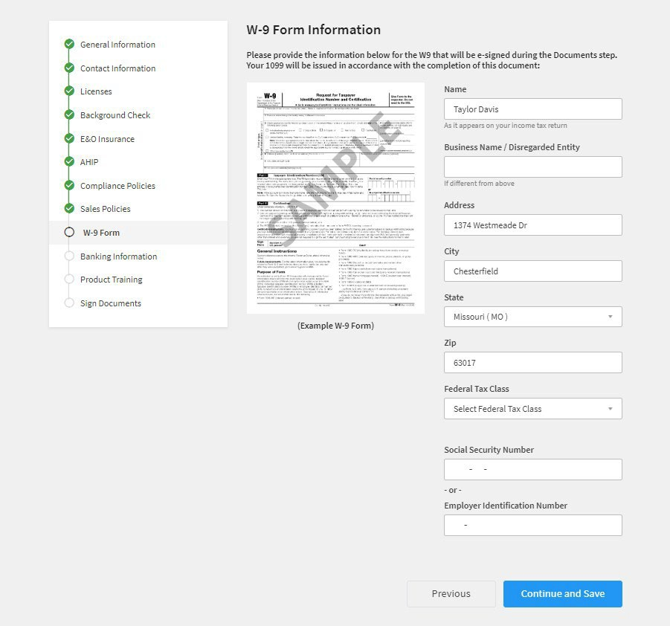

Banking Information
Complete any required fields (some will populate based on prior year certification, if applicable). Click
Continue and Save to move forward.
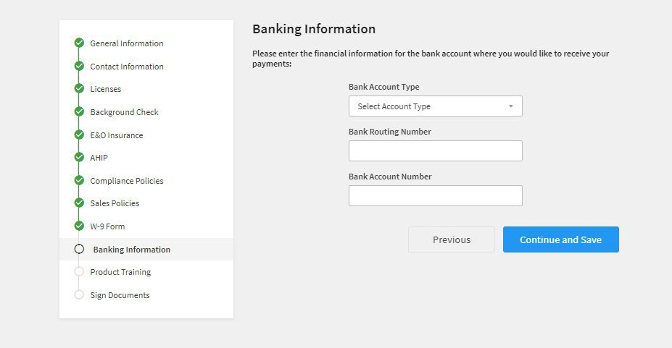

Product Training
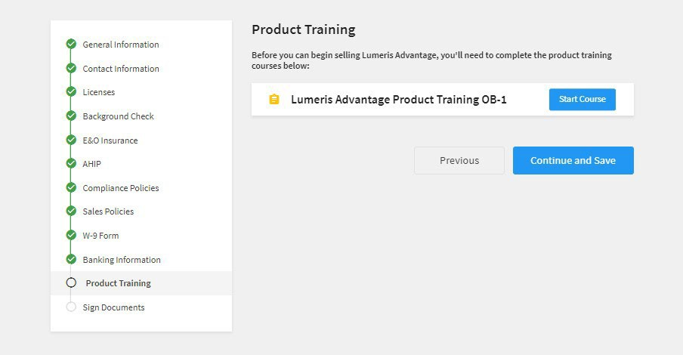
The product training course(s) on this page are required before you can begin selling. Click Start Course to view the course. Click Continue and Save to move forward.

Sign Documents
To complete your onboarding process, sign the Producer Documents.
Click View and Sign to display the form. Type your name for your electronic signature and click Submit Registration.
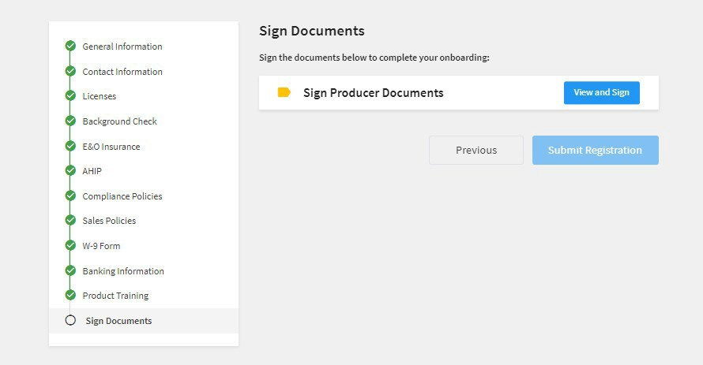

Completion
When you see the message below, you’ve completed the online process.
Once your information has been reviewed and approved, you will receive email confirmation from Producer Support, your status will be updated, and you will be read to sell.
Note: Be sure to respond to any inquiries about your background check.
