 | 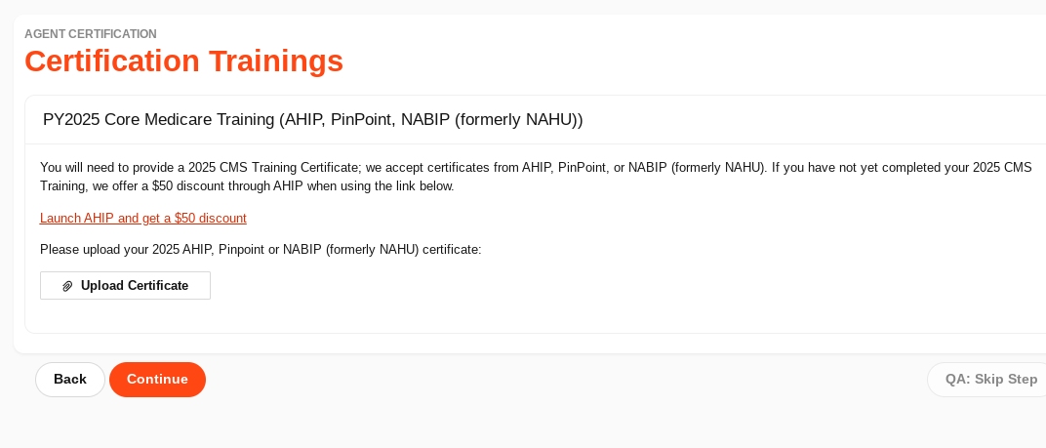
12) Certification Exam - All users | - You will access our PY2025 Devoted Health Product Training by clicking the  Launch Product Training button in the center of the page as seen below.  - This will go through a presentation that will have an interactive experience and guide you through our product oﬀerings, markets, and much more.  - Please note if you have to leave the training for any reason your progress will now be saved.  - Once you have completed the training, you will select the Continue to Exam Instructions button at the bottom of the page. Then select Continue to Exam.  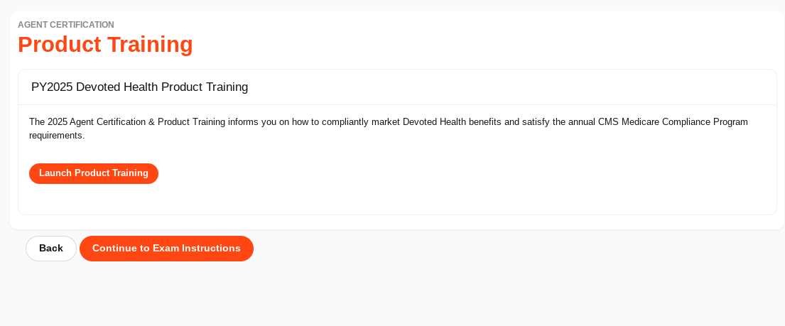

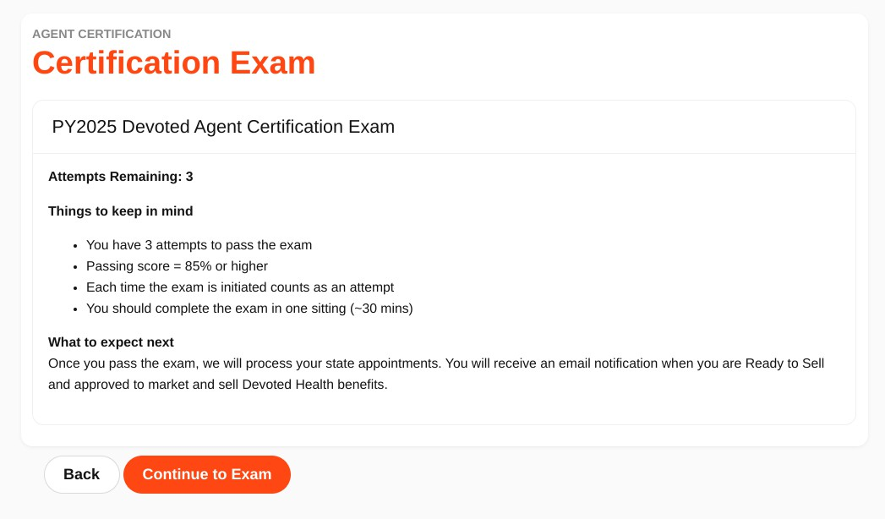
- This will open up this screen where the test will be completed.
  - You will have 3 attempts total and 1 hour per attempt. Once you start an exam you cannot exit and come back as it will count as an attempt.
  - All questions and answers will be randomized in each attempt

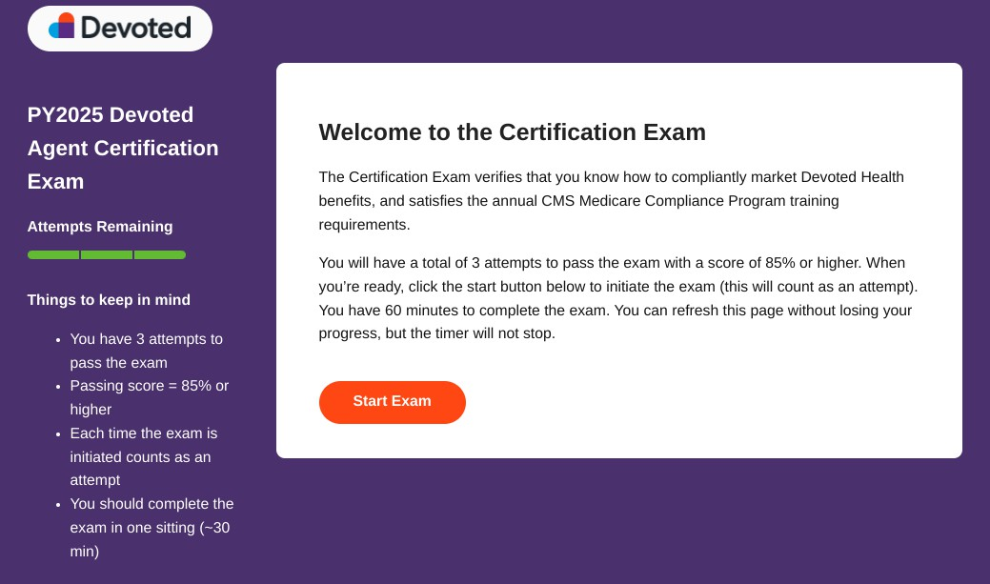

Verify and Update your Financial Information (Direct Payees only)
You can view and update your financial information in your Agent Portal account by following the easy steps outlined below:
- Login to your Agent Portal account.
  - If you need assistance with your username as password credentials please contact us.
- On the top right hand corner of the page you will see your name, select it and you will see a dropdown menu.
  - Select My Account.
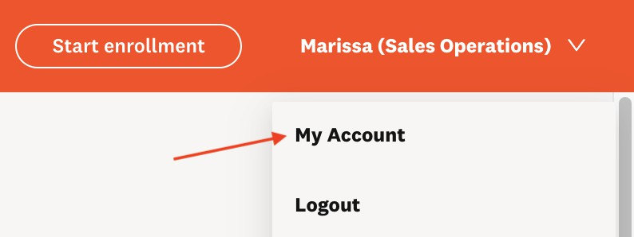
- This will display your demographic and financial information as seen below:

