AGENT CONTRACTING
- Please go to https://login.healthalliance.org/Account/Register?role=ProspectiveBroker
- On the Registration site, complete the form below:
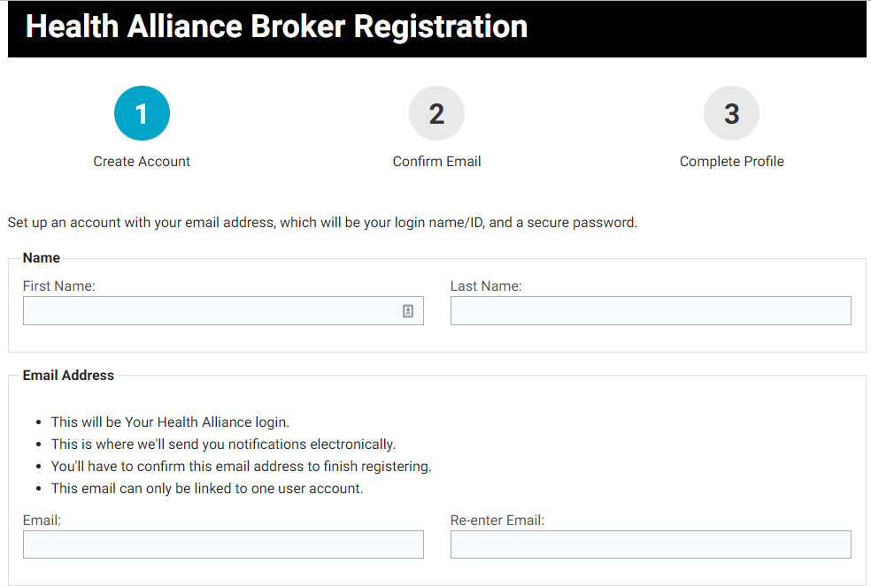
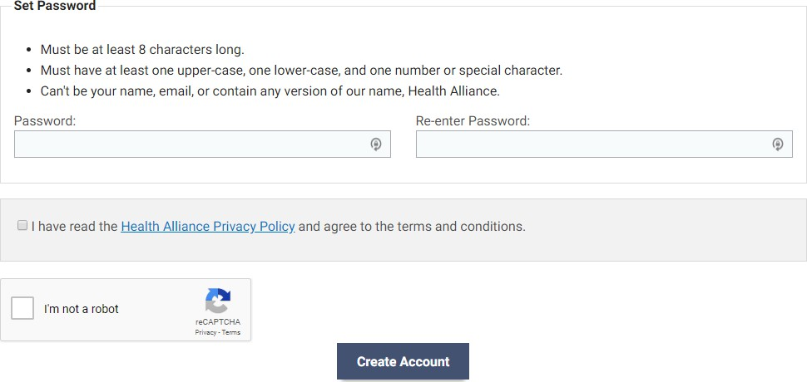

- Click Create Account
- A confirmation email will be sent
- Click Confirm
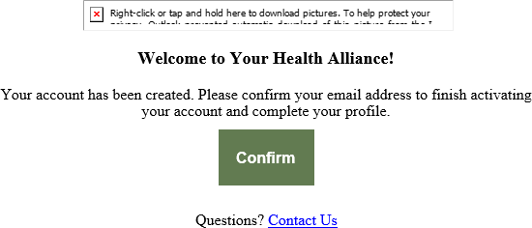
- Select a Different Account Type
- Select “I would like to become a broker for Health Alliance.”
- Click “Create a Prospective Broker Profile”

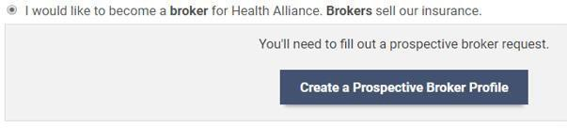
- Enter First Name
- Enter Last Name
- Enter NPN
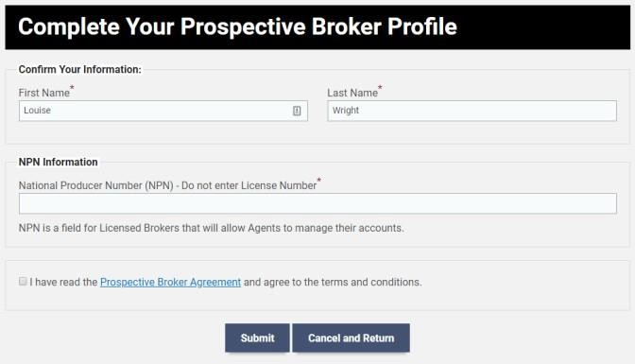
- Check mark you have read the Prospective Broker Agreement
- Click Submit
- You will then be taken to the Contracting Documents Requirements page

NOTE: You will need to complete all 4 sections, and the Legal Attestation and Electronic Signature
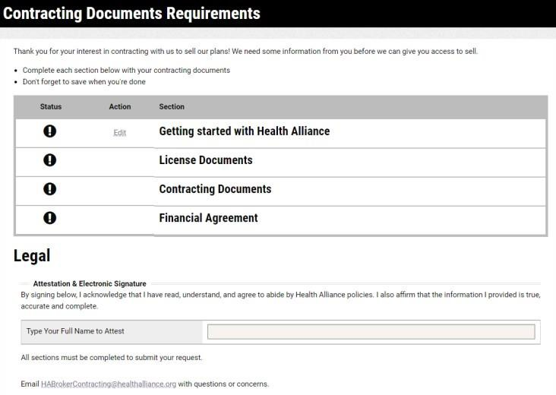
- Getting Started
  - Click Edit
    - Broker information – fill out personal and address information
    - Leave Secondary Languages blank unless applicable

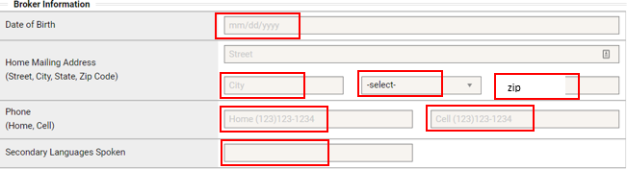
  - Products to sell
    - Select only any plans you wish to sell
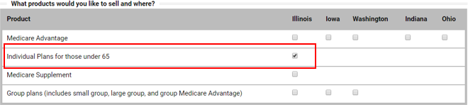

Select “I would like to be appointed under an existing agency.”
  - Enter the agency information
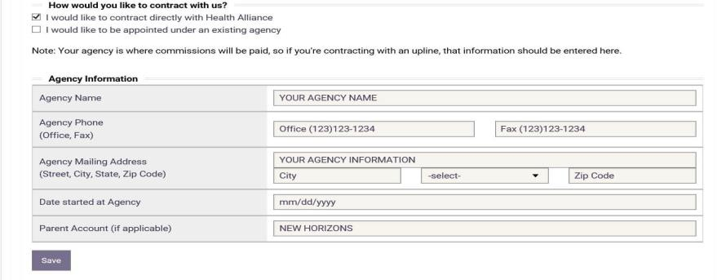
    - Agency Name:
    - Agency Phone:
    - Agency Fax:
    - Agency Mailing Address:
    - Date Started at Agency:
  - Click Save

License Documents – Select Edit
  - Click on Add Your applicable state or states Producer License Information
  - Upload a copy of your license (Choose File)
  - Effective Date of Producer license
  - Expiration Date of Producer license
  - Agency License – if you have one
  - Effective Date – if applicable
  - Expiration Date – if applicable

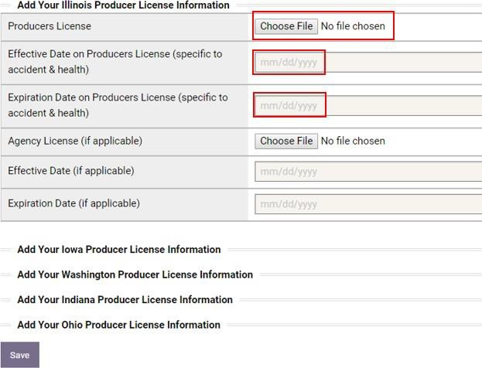
  - Click Save

Contracting Documents – Click Edit
  - Errors & Omissions Statement
    - Upload copy of E&O Certificate (Choose File)
    - Effective Date
    - Expiration Date
    - Carrier (also known as Insurer)
    - Policy Number
    - Coverage amount
  - AHIP – only needed to sell Individual Medicare
  - FFM – if applicable
    - Upload FFM Certificate (Choose File)
    - Completion Date (found on Certificate)
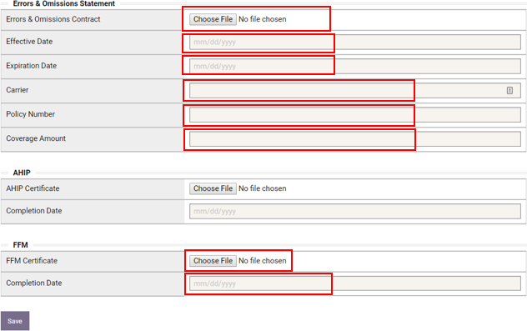
  - Click Save

Financial Agreement
  - Answer all Background/History Questions
  - Legal Documentation - Please provide explanations and upload legal documents for any “Yes” Answers, if applicable

  - Type full name to Attest
  - Click Save

Legal & Submit
  - Once all sections are completed (noted by green checkmark in the status column):
    - Type Full Name to Attest
    - Click Submit
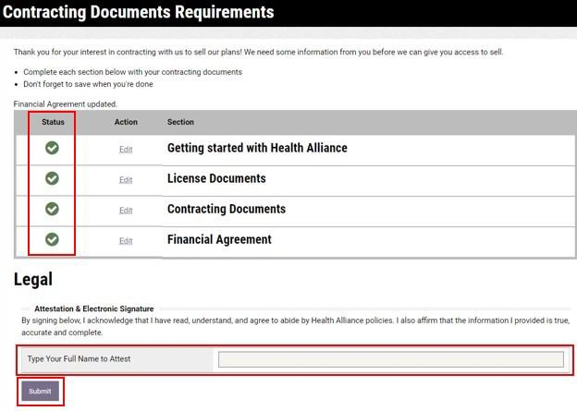

AGENT TRAINING (for Medicare Advantage only)
- In 1 – 2 business days log in to Health Alliance by clicking on the following link: www.yourhealthalliance.org
- Follow the training link located on the right-hand side of the page
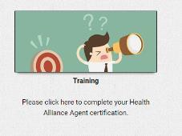
- Click the button to register for the training
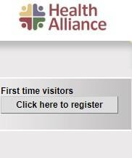
- It will prompt for the Agent ID; this is your NPN
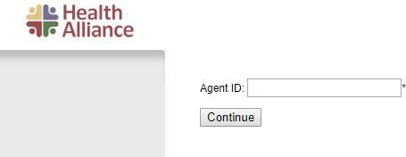
**Please Note: If your NPN does not work, it may take a few days before your training account is fully registered. Please try to register again in 1 – 2 business days.
**This training must be completed in order to keep your Health Alliance Appointment
***Effective 1/1/21, there is no commercial product training

